**SQL Assignment**

**HR Database Exercises**

1. **Write a query to display the names (first_name, last_name) using alias name “First Name", "Last Name"**

Ans. SELECT first_name "first Name", last_name"Last Name"

FROM employees;

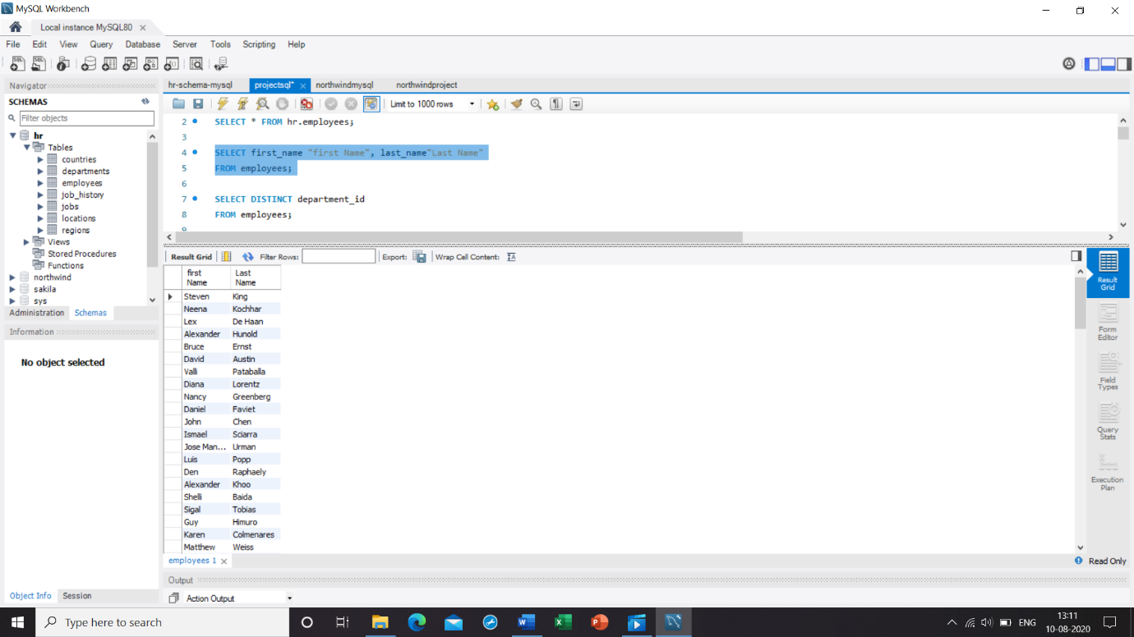

1. **Write a query to get unique department ID from employee table**

Ans. SELECT DISTINCT department_id

FROM employees;

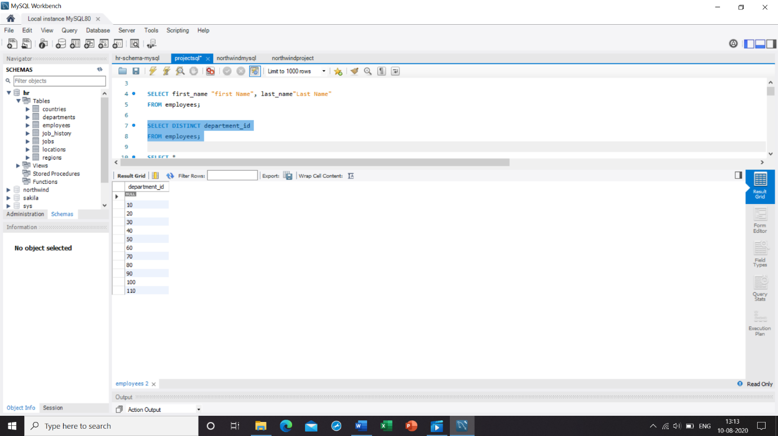

1. **Write a query to get all employee details from the employee table order by first name, A**

Ans. SELECT *

FROM employees

ORDER BY first_name DESC;

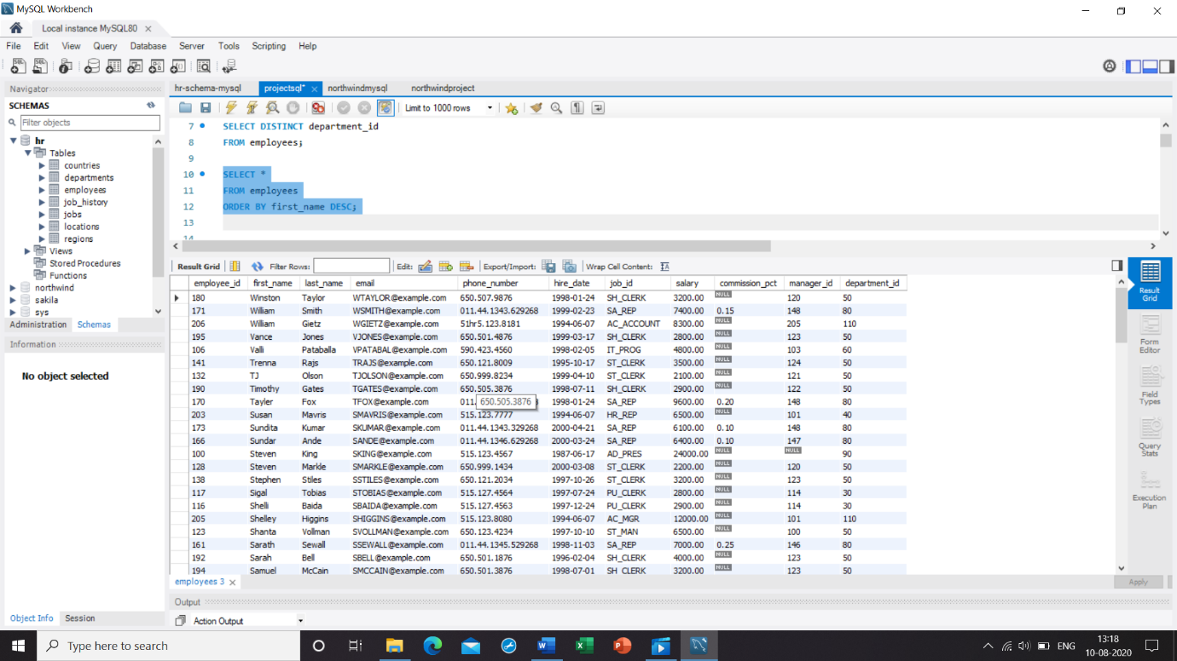

1. **Write a query to get the names (first_name, last_name), salary, PF of all the employees (PF is calculated as 15% of salary)**

Ans. SELECT first_name, last_name, salary, salary*.15PF

FROM employees;

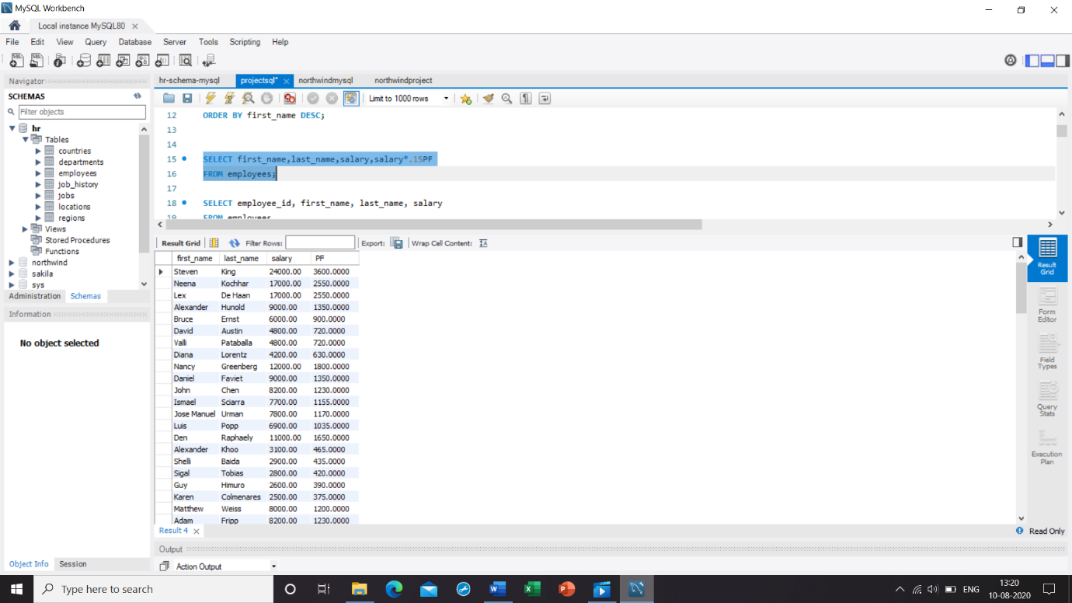

1. **Write a query to get the employee ID, names (first_name, last_name), salary in ascending order of salary**

Ans. SELECT employee_id, first_name, last_name, salary

FROM employees

ORDER BY salary ASC;

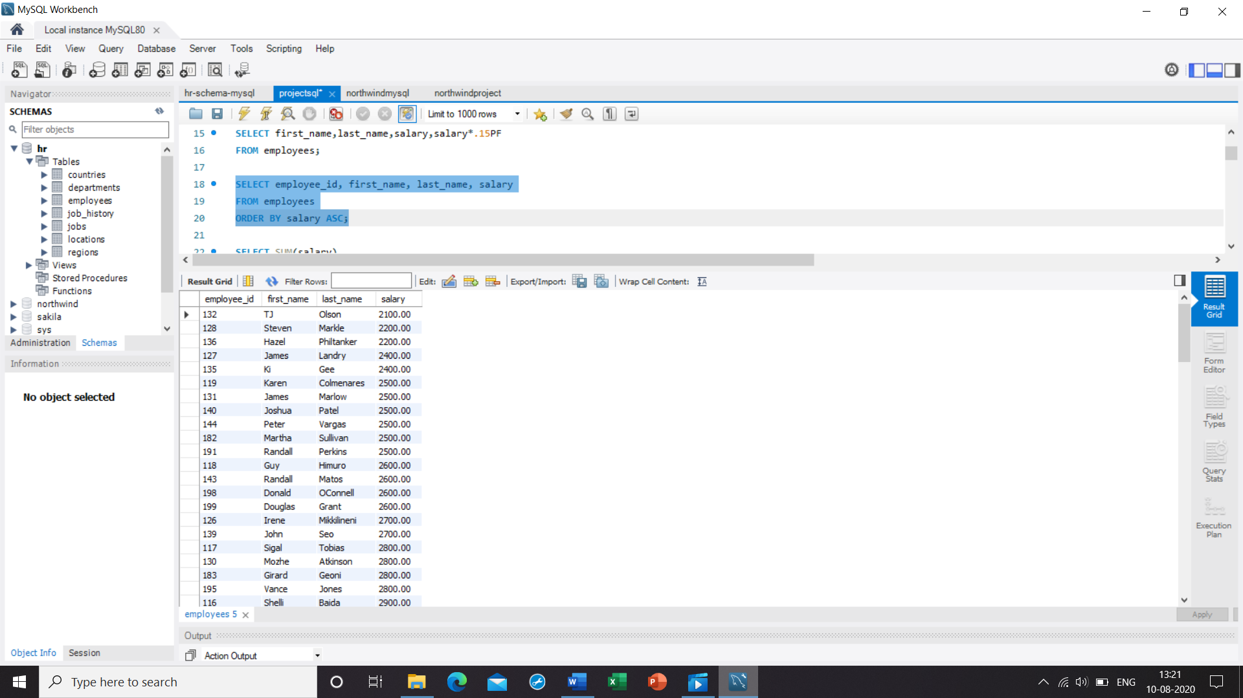

1. **Write a query to get the total salaries payable to employees**

Ans. SELECT SUM(salary)

FROM employees;

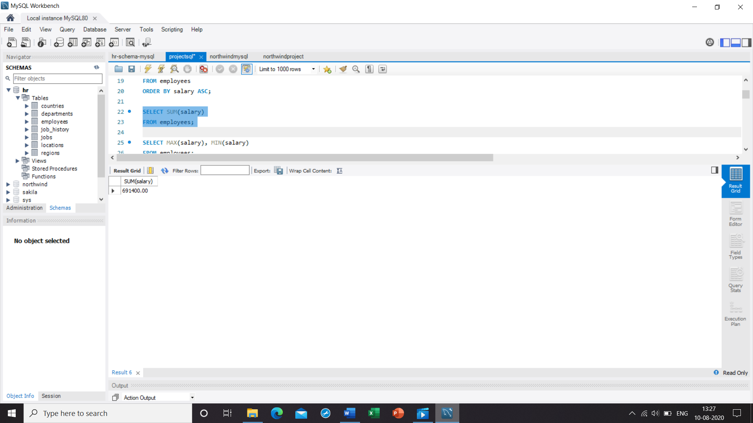

**7. Write a query to get the maximum and minimum salary from employees table**

Ans. SELECT MAX(salary), MIN(salary)

FROM employees;

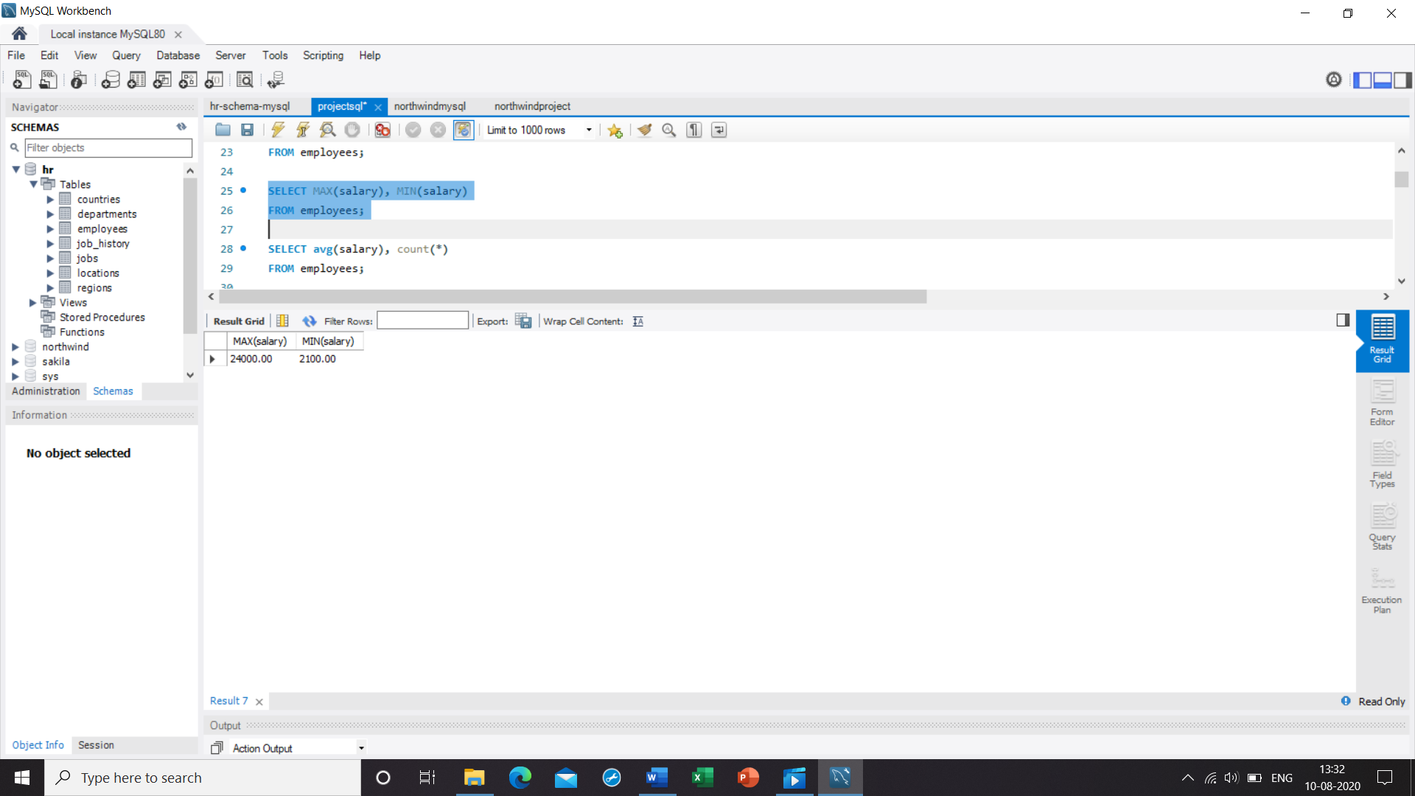

8. **Write a query to get the average salary and number of employees in the employees table**

Ans. SELECT avg(salary), count(*)

FROM employees;

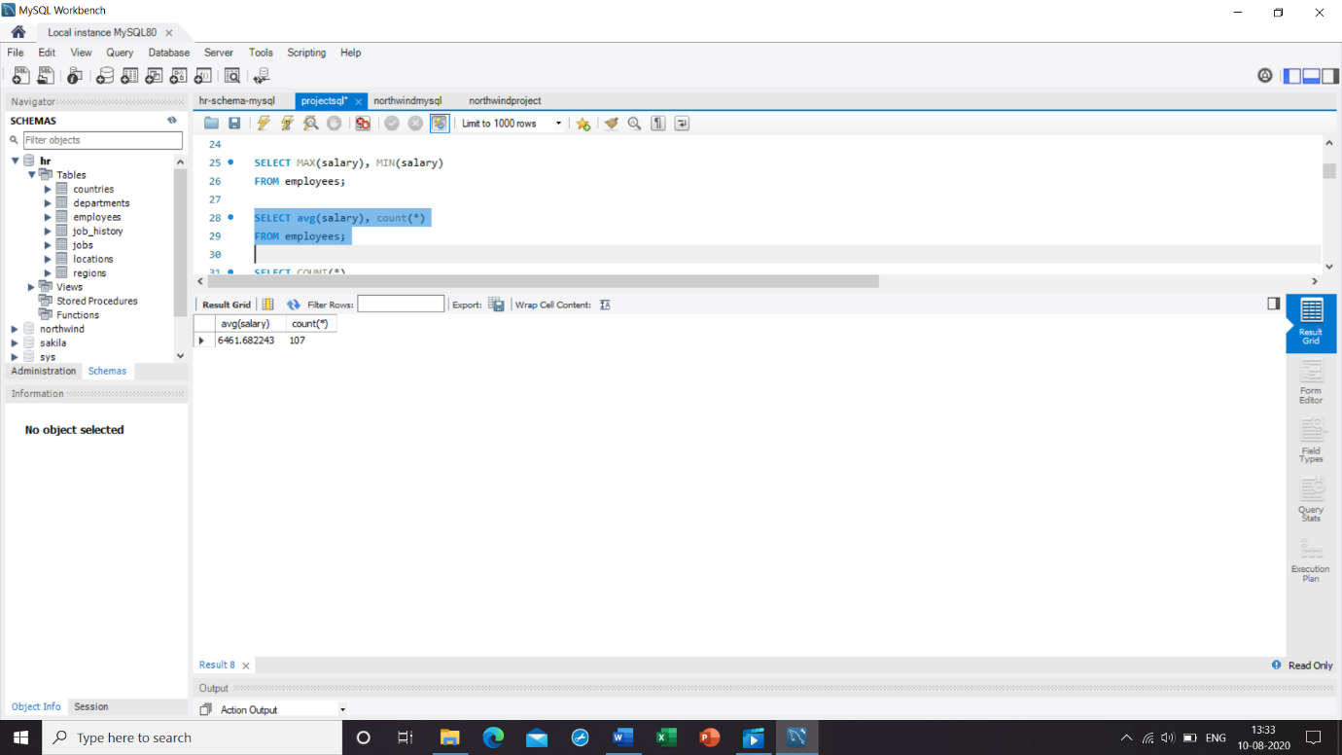

9. **Write a query to get the number of employees working with the company**

Ans. SELECT COUNT(*)

FROM employees;

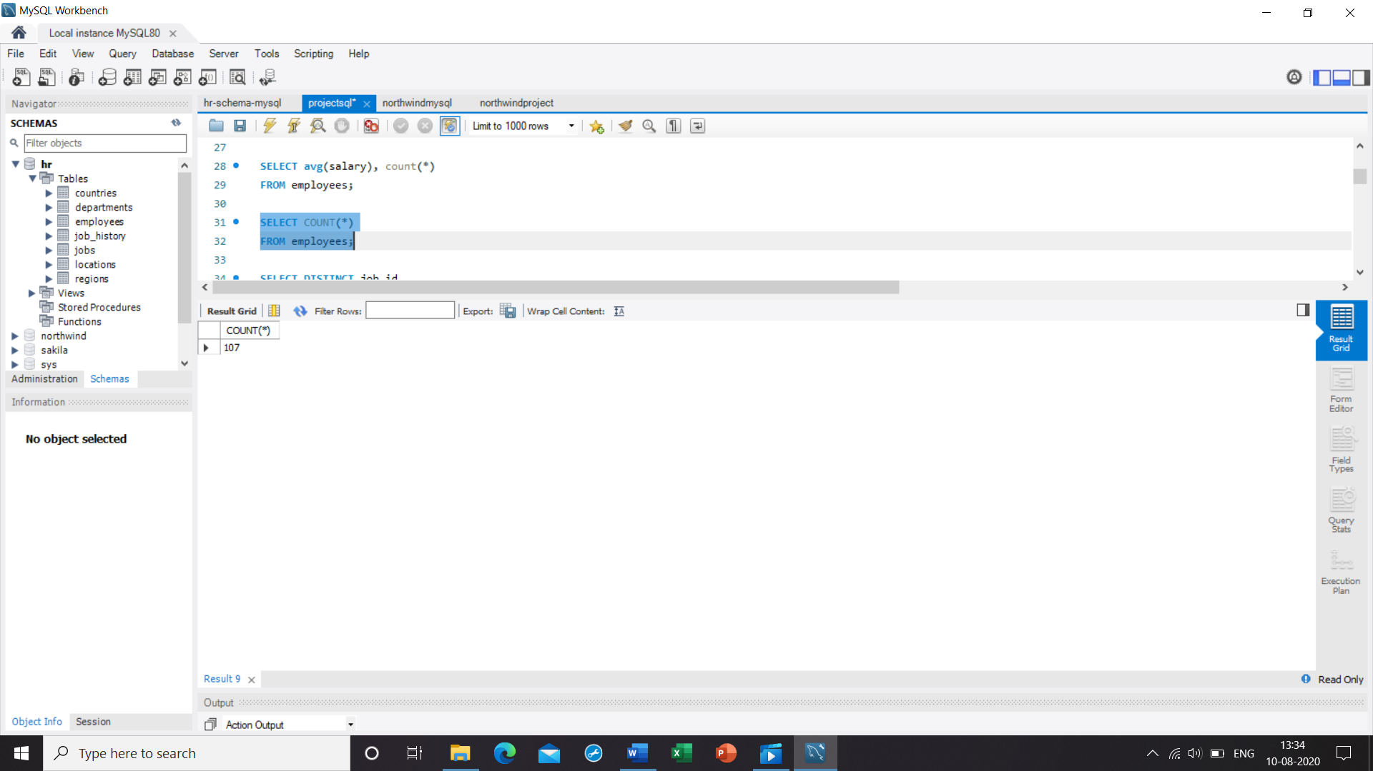

10. **Write a query to get the number of jobs available in the employees table**

Ans. SELECT DISTINCT job_id

FROM employees;

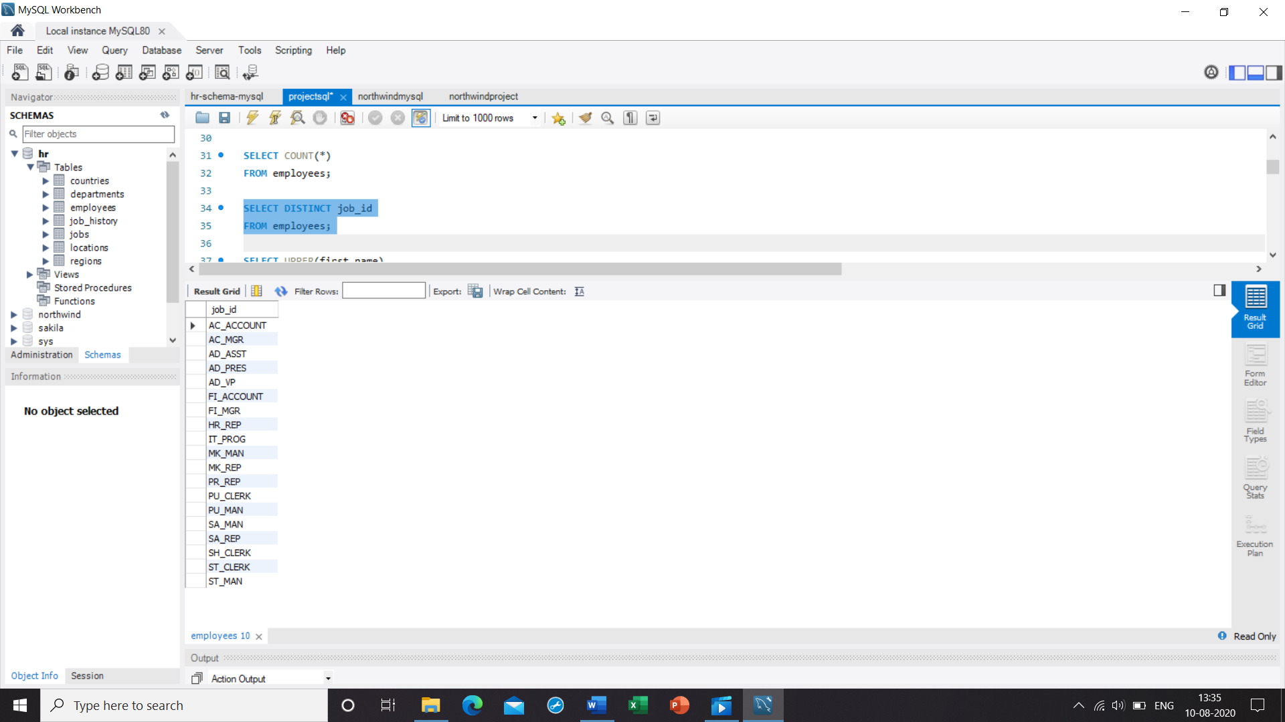

**11. Write a query get all first name from employees table in upper case**

Ans. SELECT UPPER(first_name)

FROM employees;

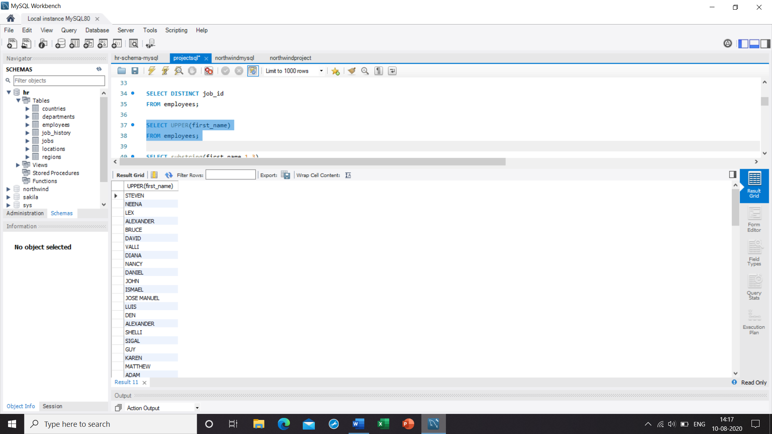

12. **Write a query to get the first 3 characters of first name from employees table**

Ans. SELECT substring(first_name,1,3)

FROM employees;

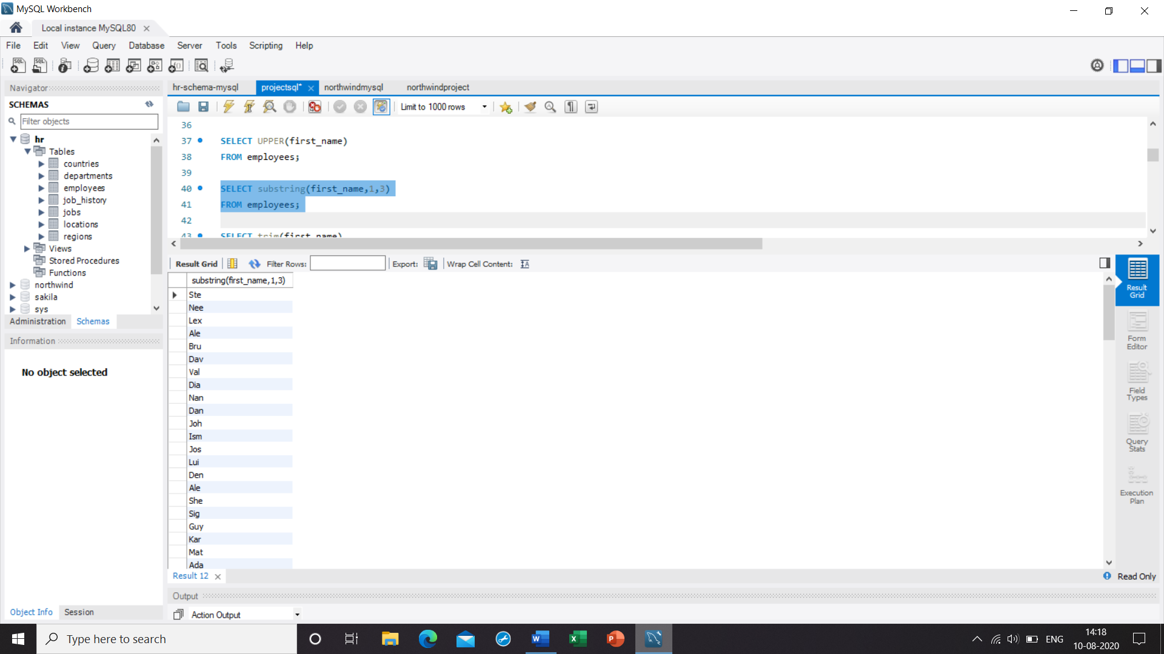

13. **Write a query to get first name from employees table after removing white spaces from both side**

Ans. SELECT trim(first_name)

FROM employees;

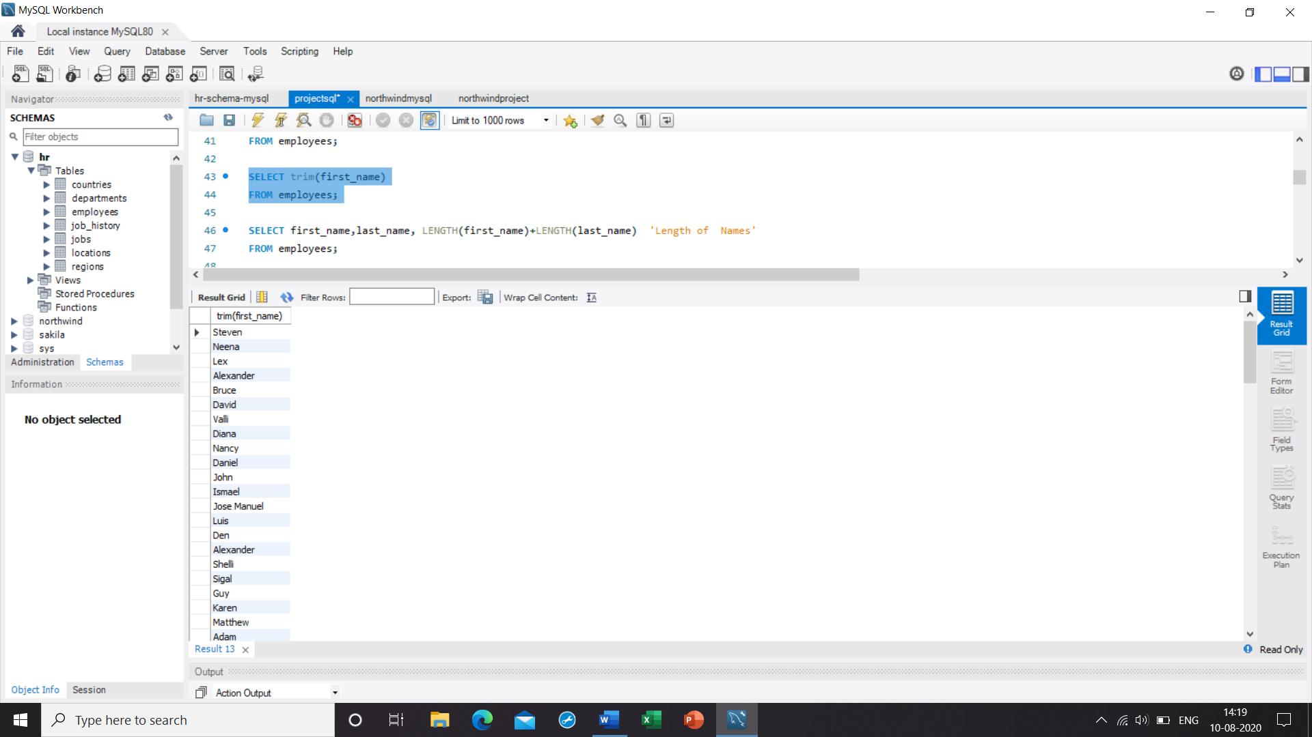

14. **Write a query to get the length of the employee names (first_name, last_name) from employees table**

Ans. SELECT first_name,last_name, LENGTH(first_name)+LENGTH(last_name) 'Length of Names'

FROM employees;

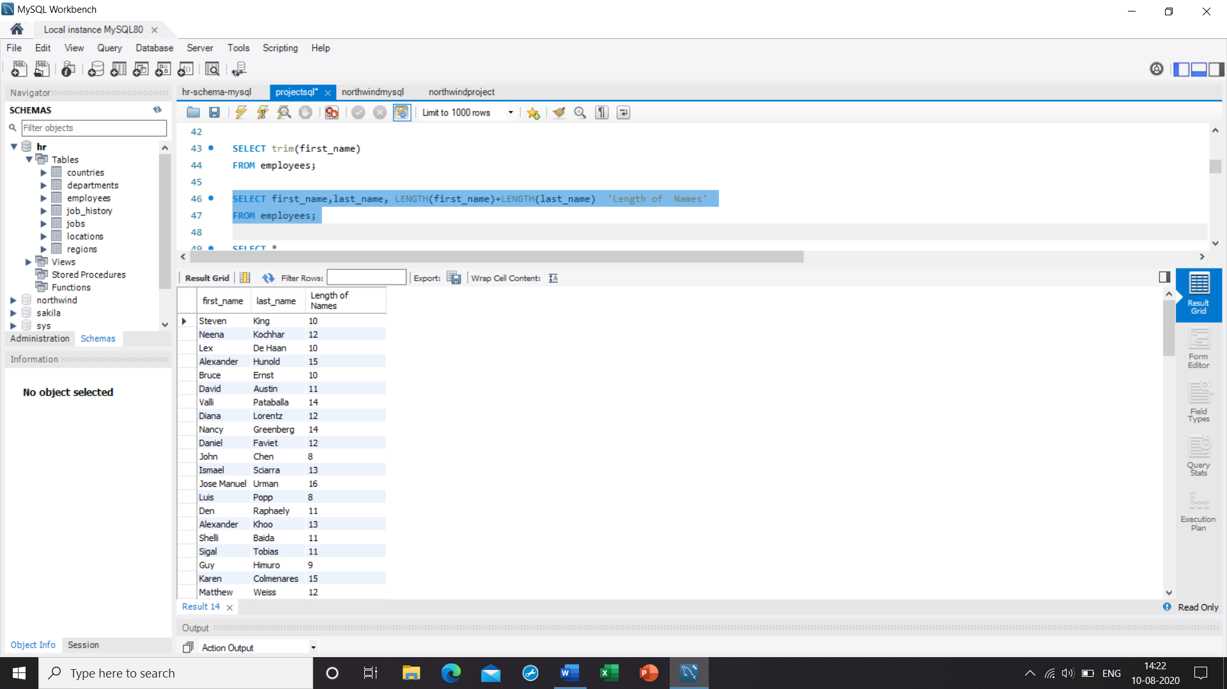

15. **Write a query to check if the first_name fields of the employees table contains numbers**

Ans. SELECT *

FROM employees

WHERE first_name REGEXP '[0-9]';

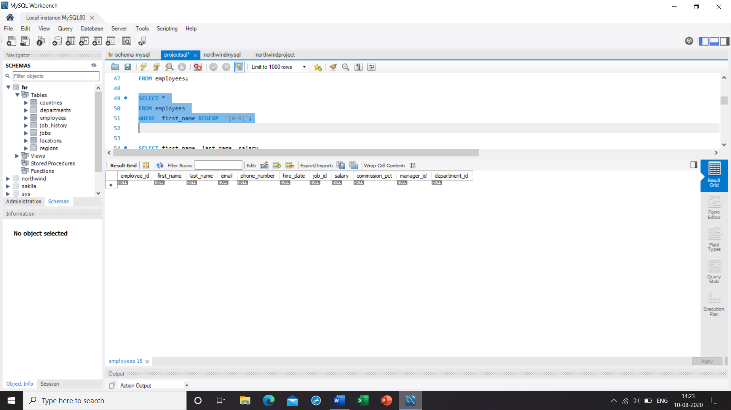

**16. Write a query to display the name (first_name, last_name) and salary for all employees whose salary is not in the range $10,000 through $15,000**

Ans. SELECT first_name, last_name, salary

FROM employees

WHERE salary NOT BETWEEN 10000 AND 15000;

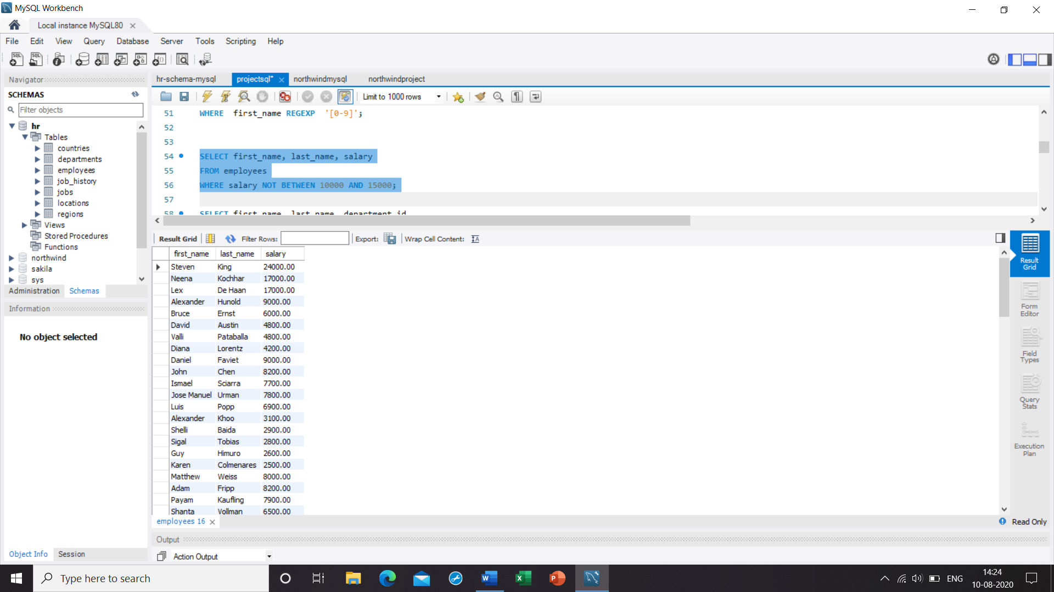

17. **Write a query to display the name (first_name, last_name) and department ID of all employees in departments 30 or 100 in ascending order**

Ans. SELECT first_name, last_name, department_id

FROM employees

WHERE department_id IN (30, 100)

ORDER BY department_id ASC;

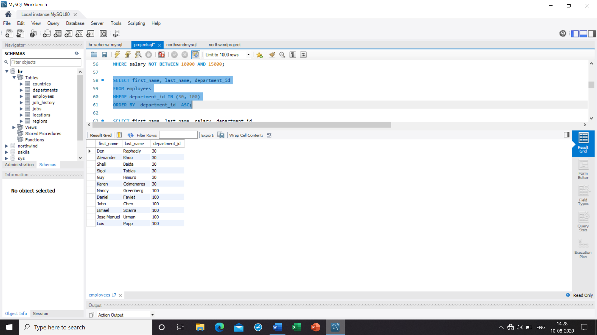

18. **Write a query to display the name (first_name, last_name) and salary for all employees whose salary is not in the range $10,000 through $15,000 and are in department 30 or 100**

Ans. SELECT first_name, last_name, salary, department_id

FROM employees

WHERE salary NOT BETWEEN 10000 AND 15000

AND department_id IN (30, 100);

19**. Write a query to display the name (first_name, last_name) and hire date for all employees who were hired in 1987**

Ans. SELECT first_name, last_name, hire_date

FROM employees

WHERE YEAR(hire_date) LIKE '1987%';

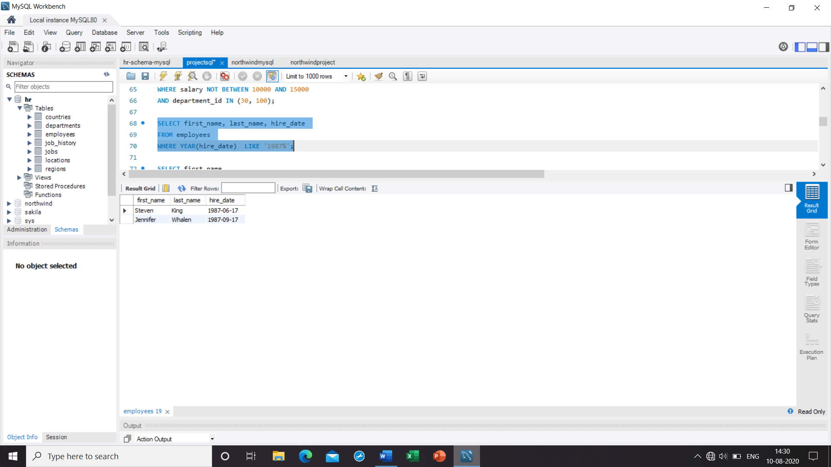

20. **Write a query to display the first_name of all employees who have both "b" and "c" in their first name**

Ans. SELECT first_name

FROM employees

WHERE first_name LIKE '%b%'

AND first_name LIKE '%c%';

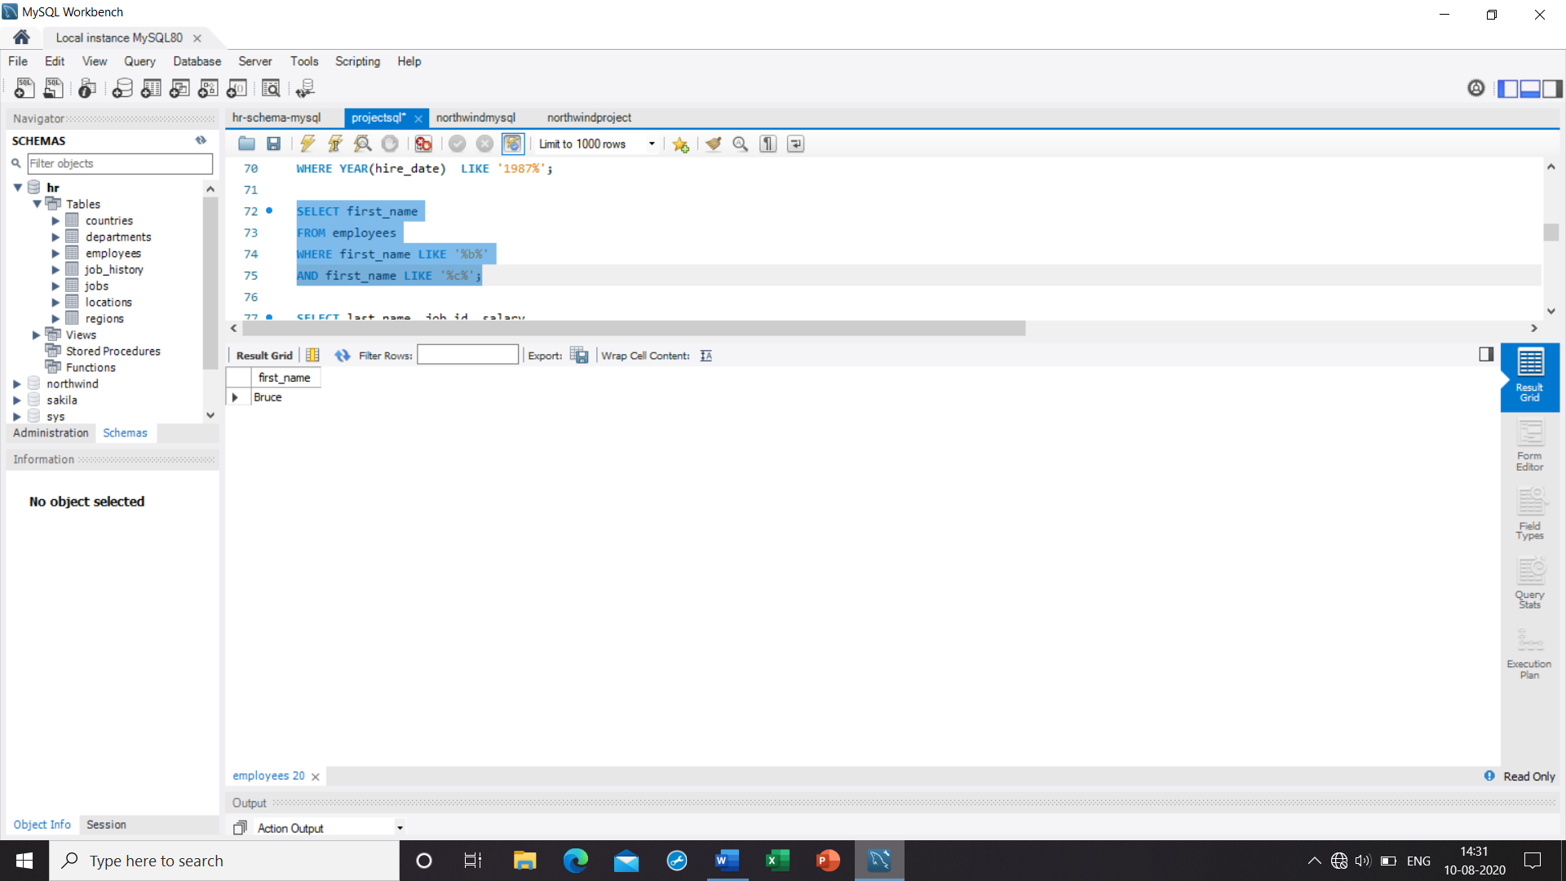

21. **Write a query to display the last name, job, and salary for all employees whose job is that of a Programmer or a Shipping Clerk, and whose salary is not equal to $4,500, $10,000, or $15,000**

Ans. SELECT last_name, job_id, salary

FROM employees

WHERE job_id IN ('IT_PROG', 'SH_CLERK')

AND salary NOT IN (4500,10000, 15000);

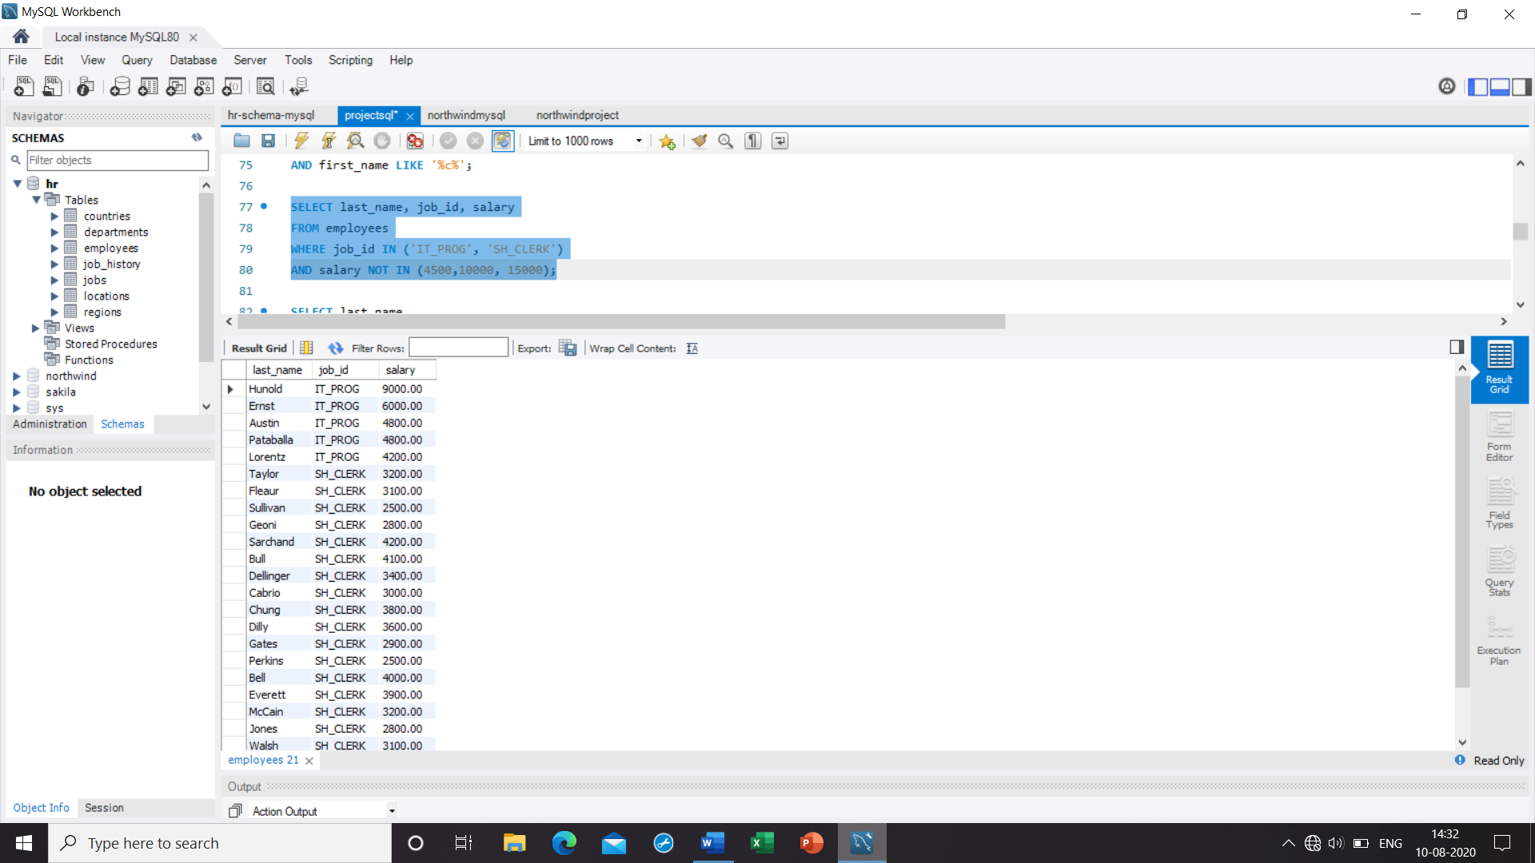

22. **Write a query to display the last name of employees whose names have exactly 6 characters**

Ans. SELECT last_name

FROM employees

WHERE last_name LIKE '______';

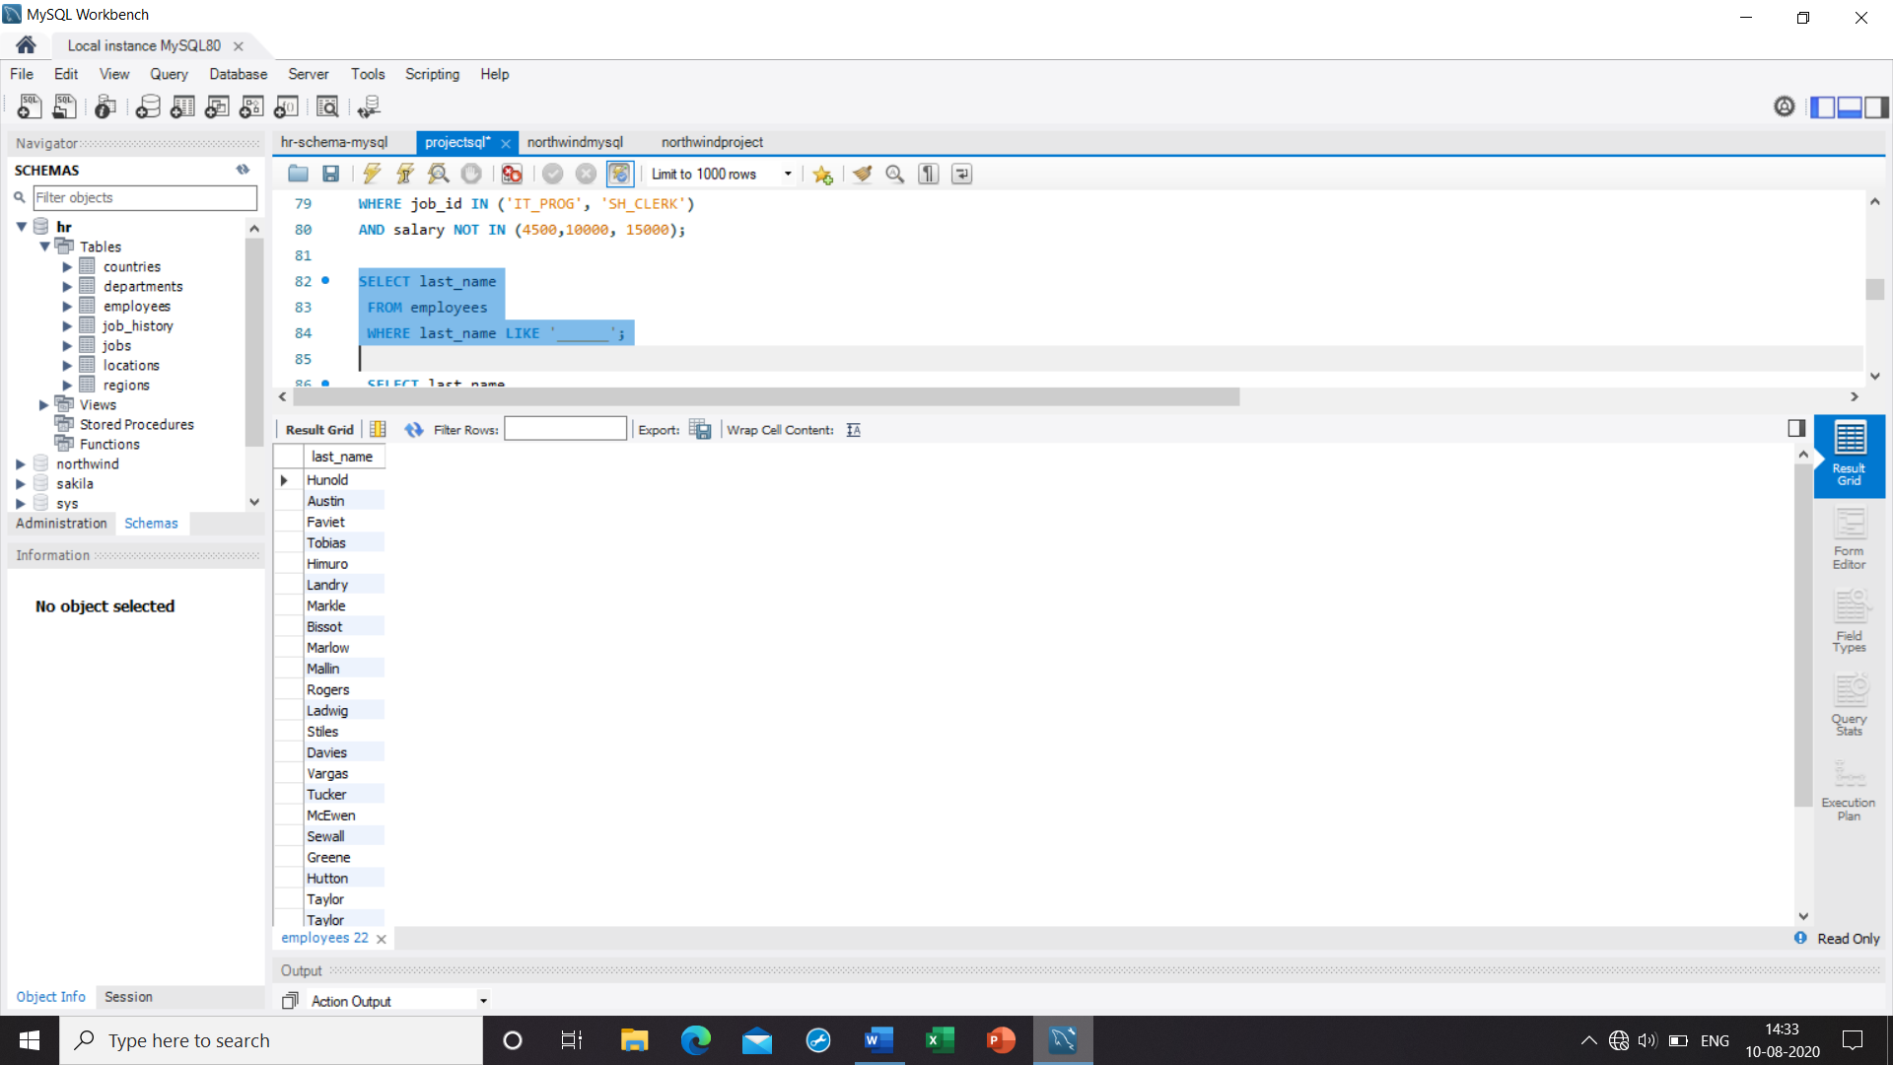

23. **Write a query to display the last name of employees having 'e' as the third character**

Ans. SELECT last_name

FROM employees

WHERE last_name LIKE '__e%';

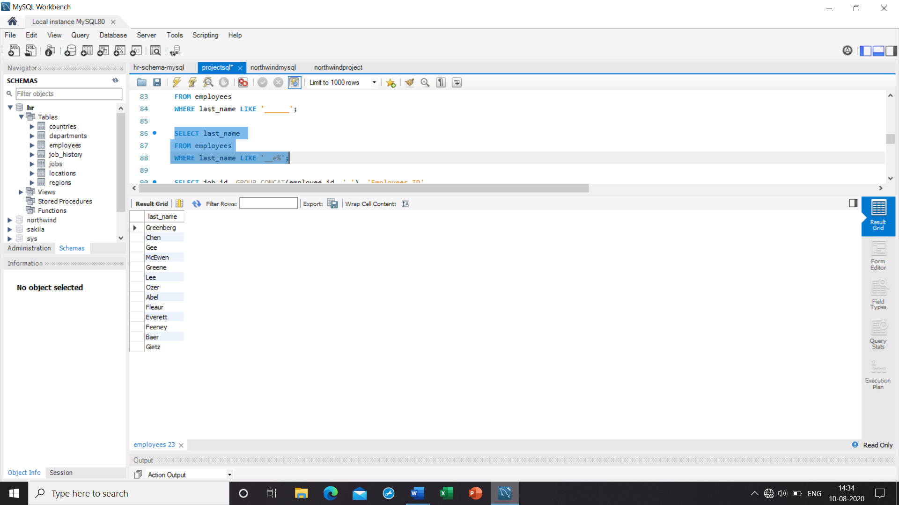

24**. Write a query to get the job_id and related employee's id**

|  |  |
| --- | --- |
| **Partial output of the query : job_id** | **Employees ID** |
| **AC_ACCOUNT** | **206** |
| **AC_MGR** | **205** |
| **AD_ASST** | **200** |
| **AD_PRES** | **100** |
| **AD_VP** | **101 ,102** |
| **FI_ACCOUNT** | **110 ,113 ,111 ,109 ,112** |

Ans. SELECT job_id, GROUP_CONCAT(employee_id, ' ') 'Employees ID'

FROM employees GROUP BY job_id;

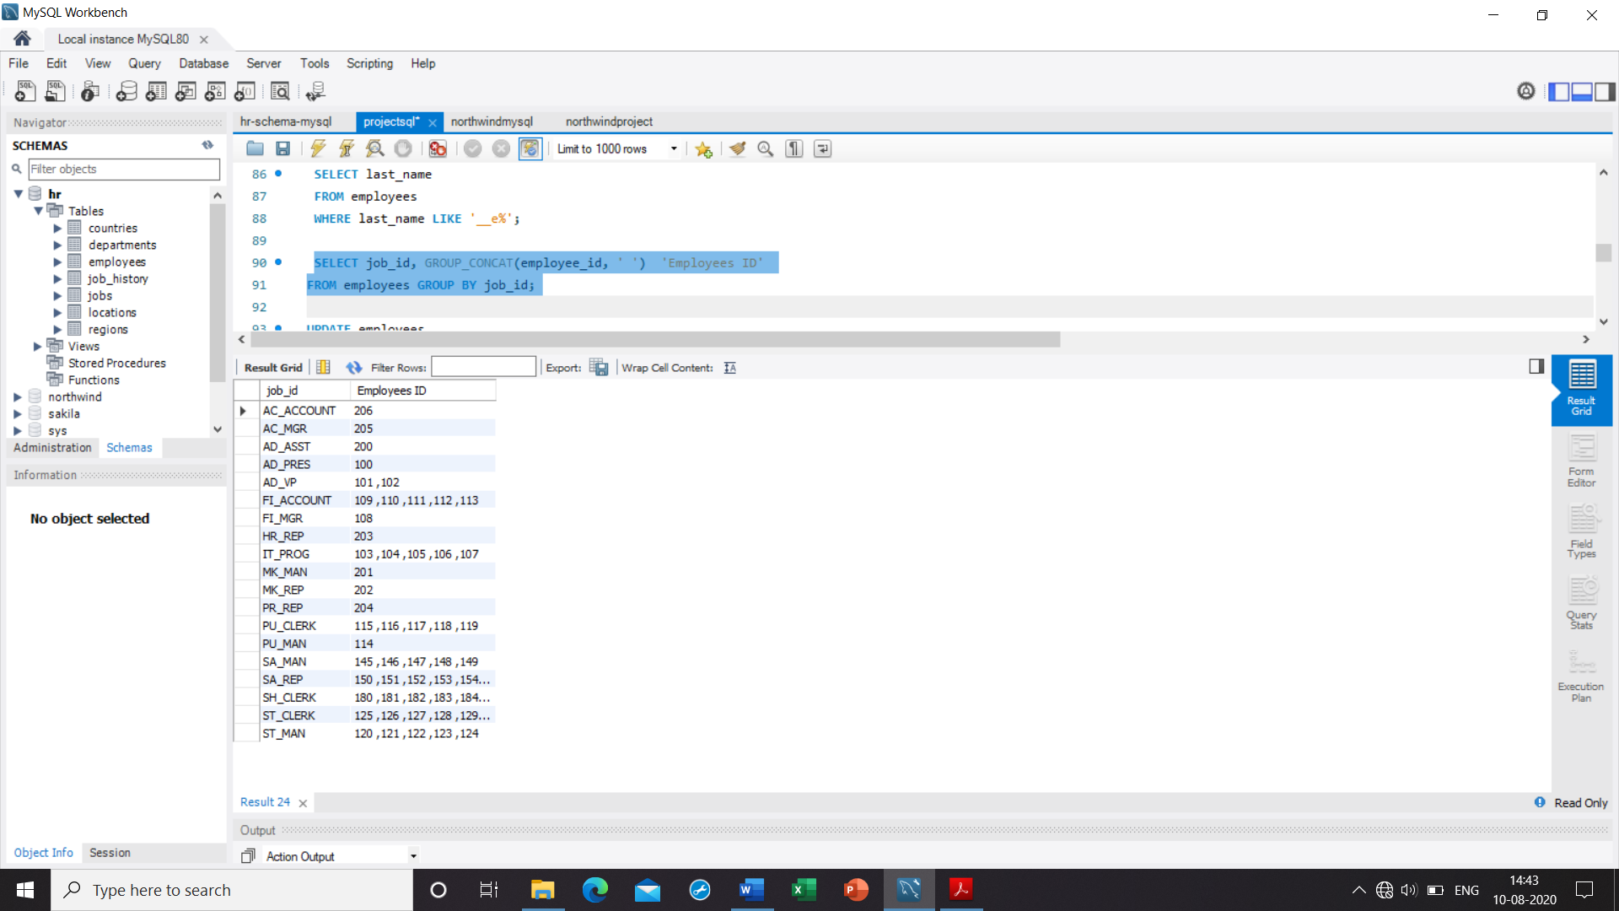

25. **Write a query to update the portion of the phone_number in the employees table, within the phone number the substring '124' will be replaced by '999'**

Ans. UPDATE employees

SET phone_number = REPLACE(phone_number, '124', '999')

WHERE phone_number LIKE '%124%';

**OR**

**select phone_number from employees;**

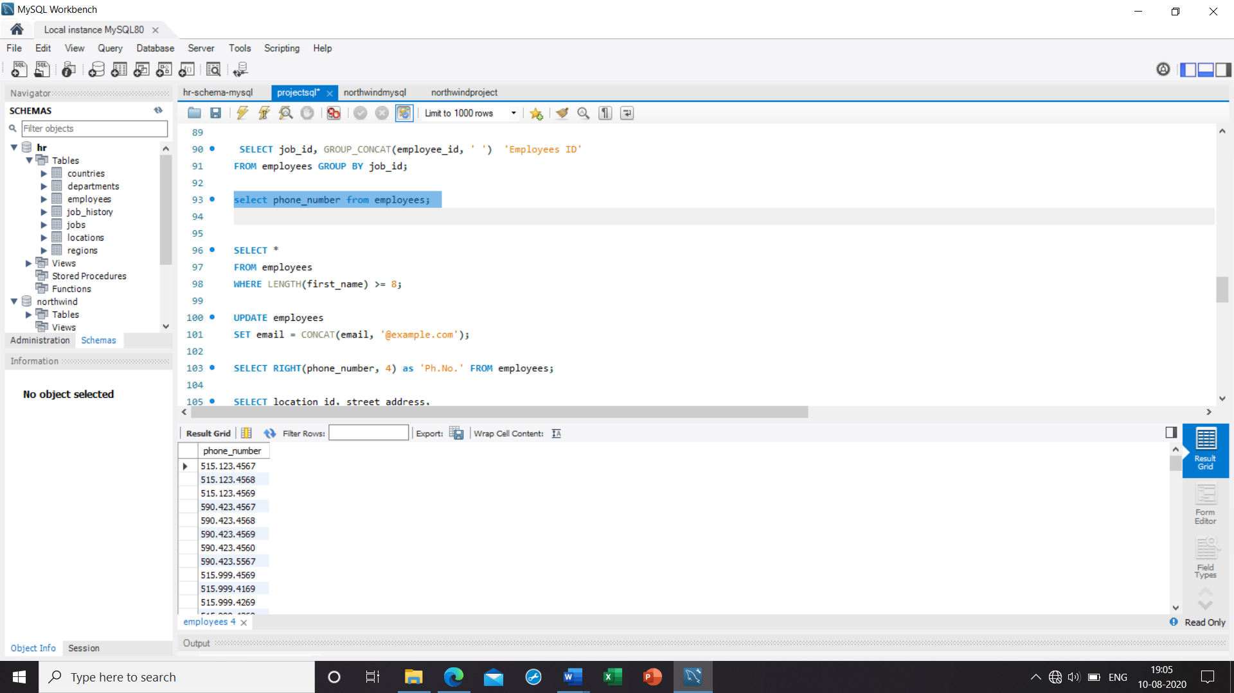

26**. Write a query to get the details of the employees where the length of the first name greater than or equal to 8**

Ans. SELECT *

FROM employees

WHERE LENGTH(first_name) >= 8;

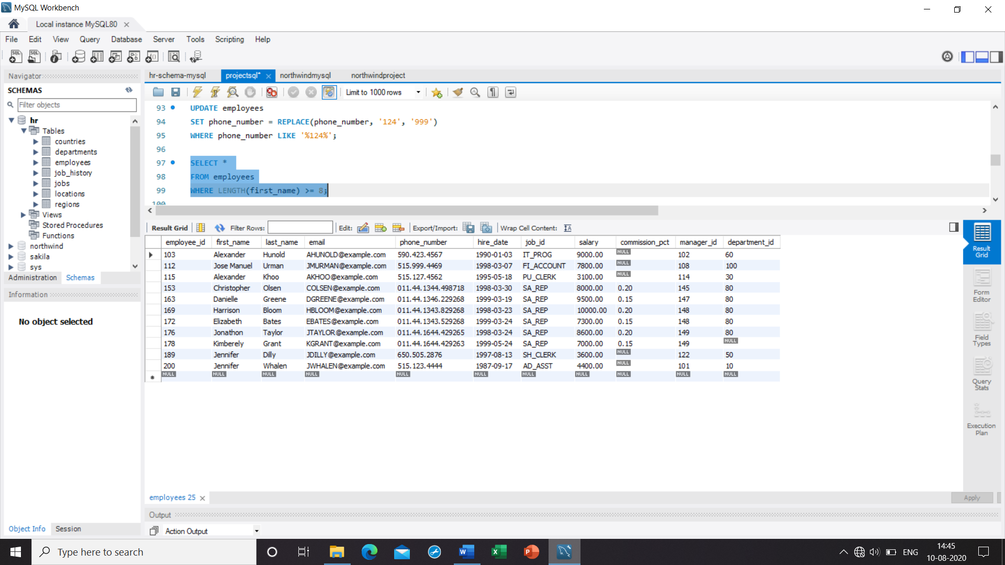

27. **Write a query to append '@example.com' to email field**

Ans. select email

from employees;

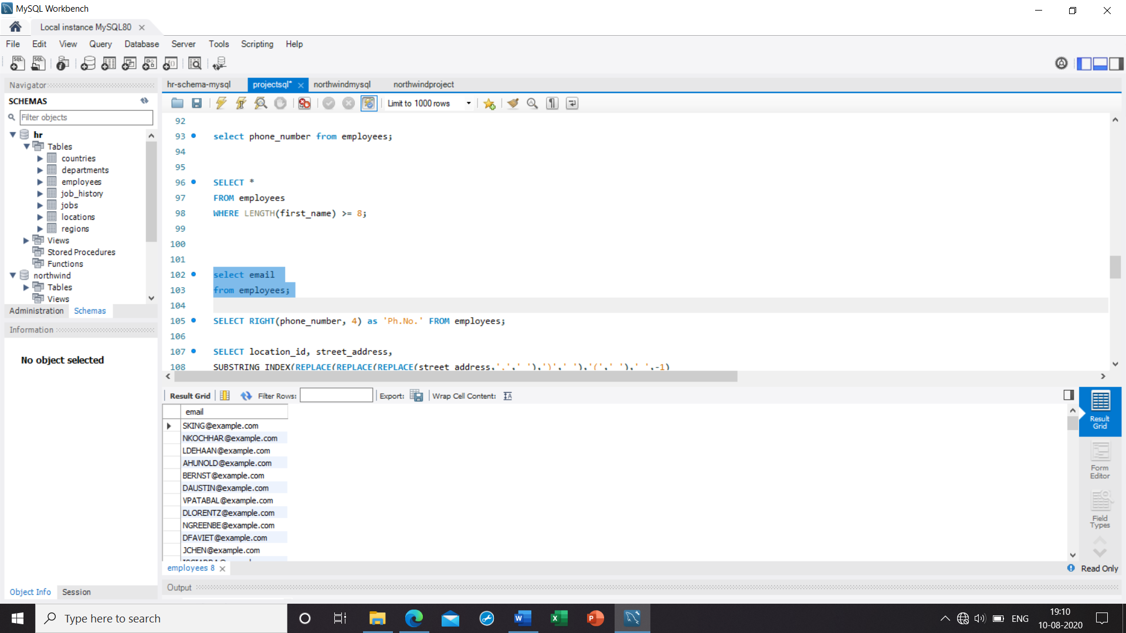

28**. Write a query to extract the last 4 character of phone numbers**

Ans. SELECT RIGHT(phone_number, 4) as 'Ph.No.' FROM employees;

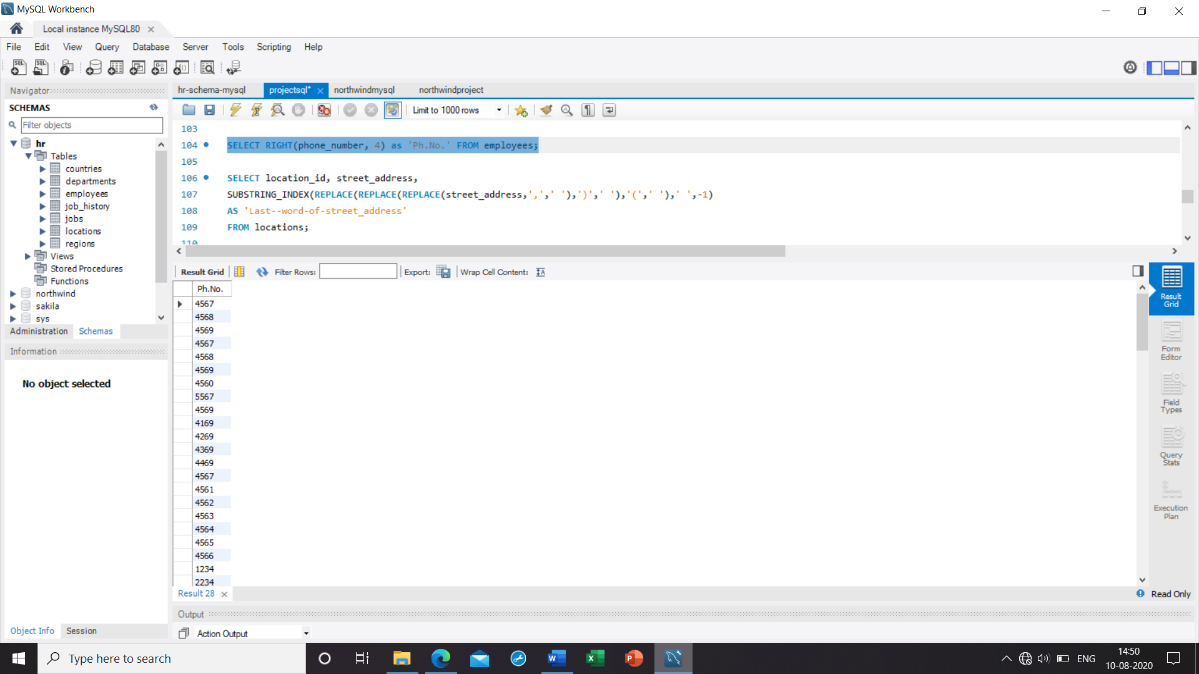

29. **Write a query to get the last word of the street address**

Ans. SELECT location_id, street_address,

SUBSTRING_INDEX(REPLACE(REPLACE(REPLACE(street_address,',',' '),')',' '),'(',' '),' ',-1)

AS 'Last--word-of-street_address'

FROM locations;

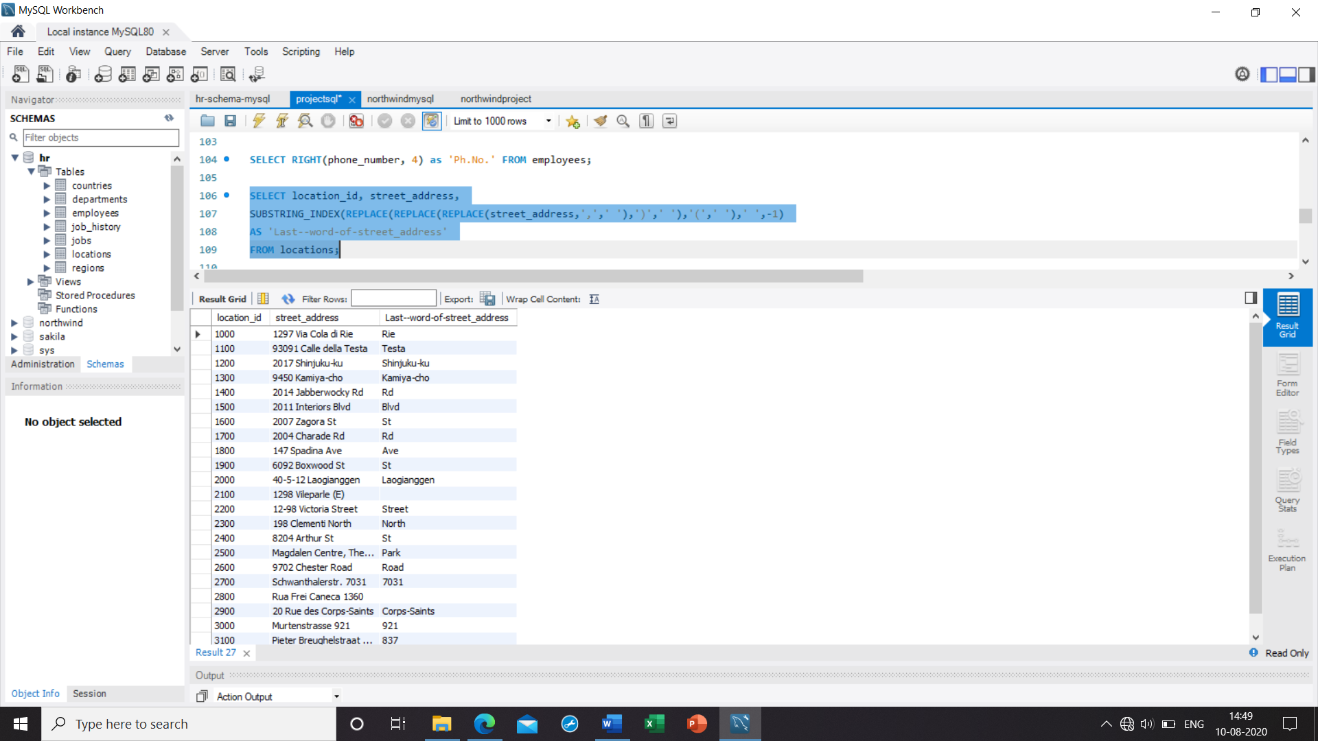

30**. Write a query to get the locations that have minimum street length**

Ans. SELECT * FROM locations

WHERE LENGTH(street_address) <= (SELECT MIN(LENGTH(street_address))

FROM locations);

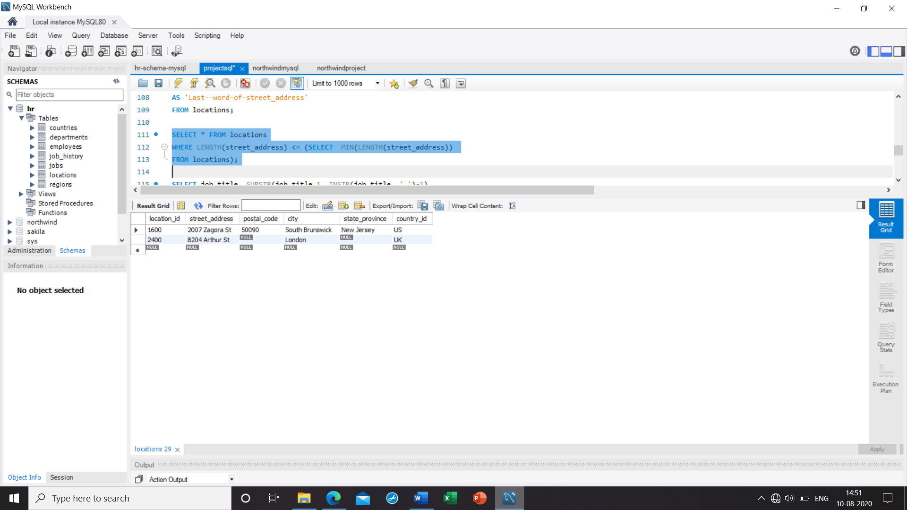

31. **Write a query to display the first word from those job titles which contains more than one words**

Ans. SELECT job_title, SUBSTR(job_title,1, INSTR(job_title, ' ')-1)

FROM jobs;

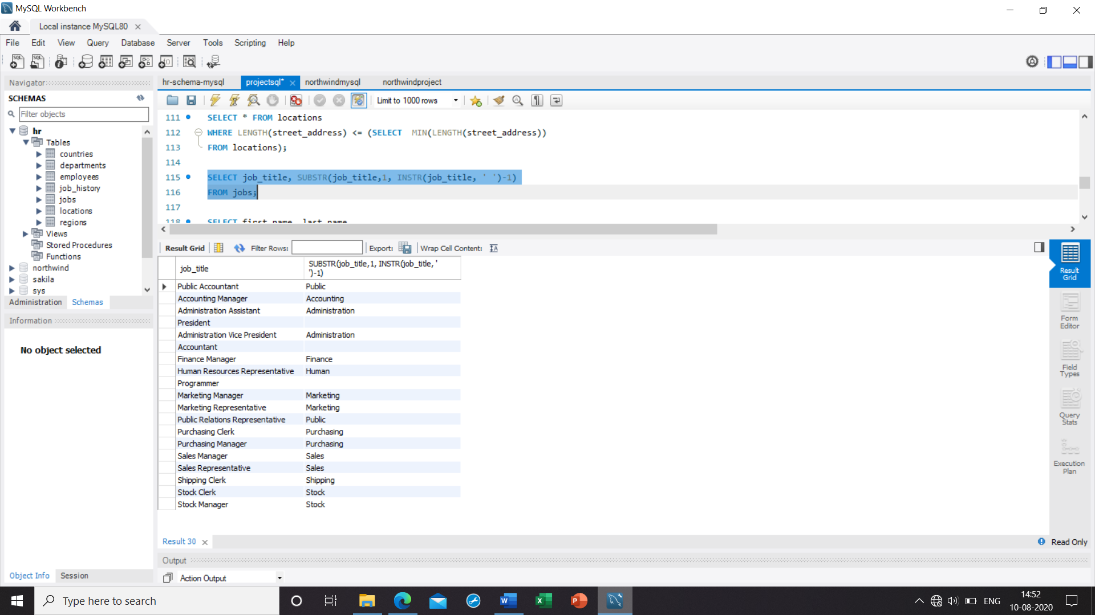

32. **Write a query to display the length of first name for employees where last name contain character 'c' after 2nd position**

Ans. SELECT first_name, last_name

FROM employees

WHERE INSTR(last_name,'C') > 2;

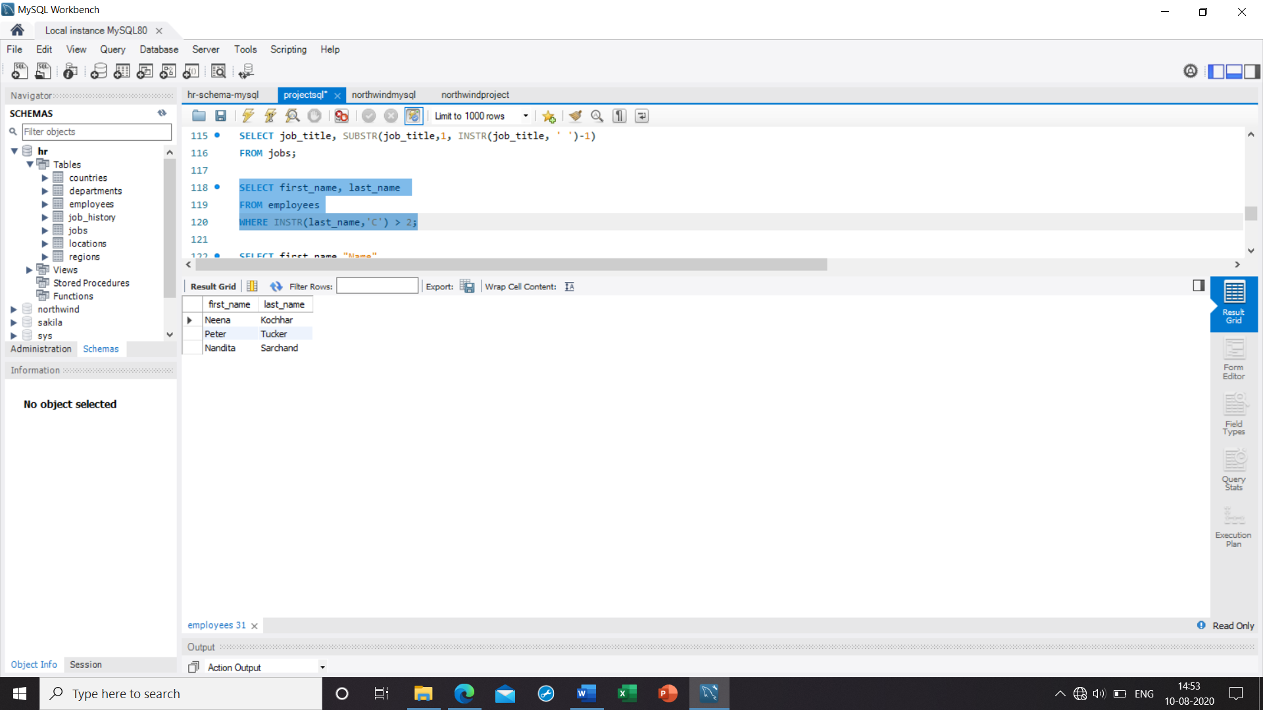

33. **Write a query that displays the first name and the length of the first name for all employees whose name starts with the letters 'A', 'J' or 'M'. Give each column an appropriate label. Sort the results by the employees' first names**

Ans. SELECT first_name "Name",

LENGTH(first_name) "Length"

FROM employees

WHERE first_name LIKE 'J%'

OR first_name LIKE 'M%'

OR first_name LIKE 'A%'

ORDER BY first_name ;

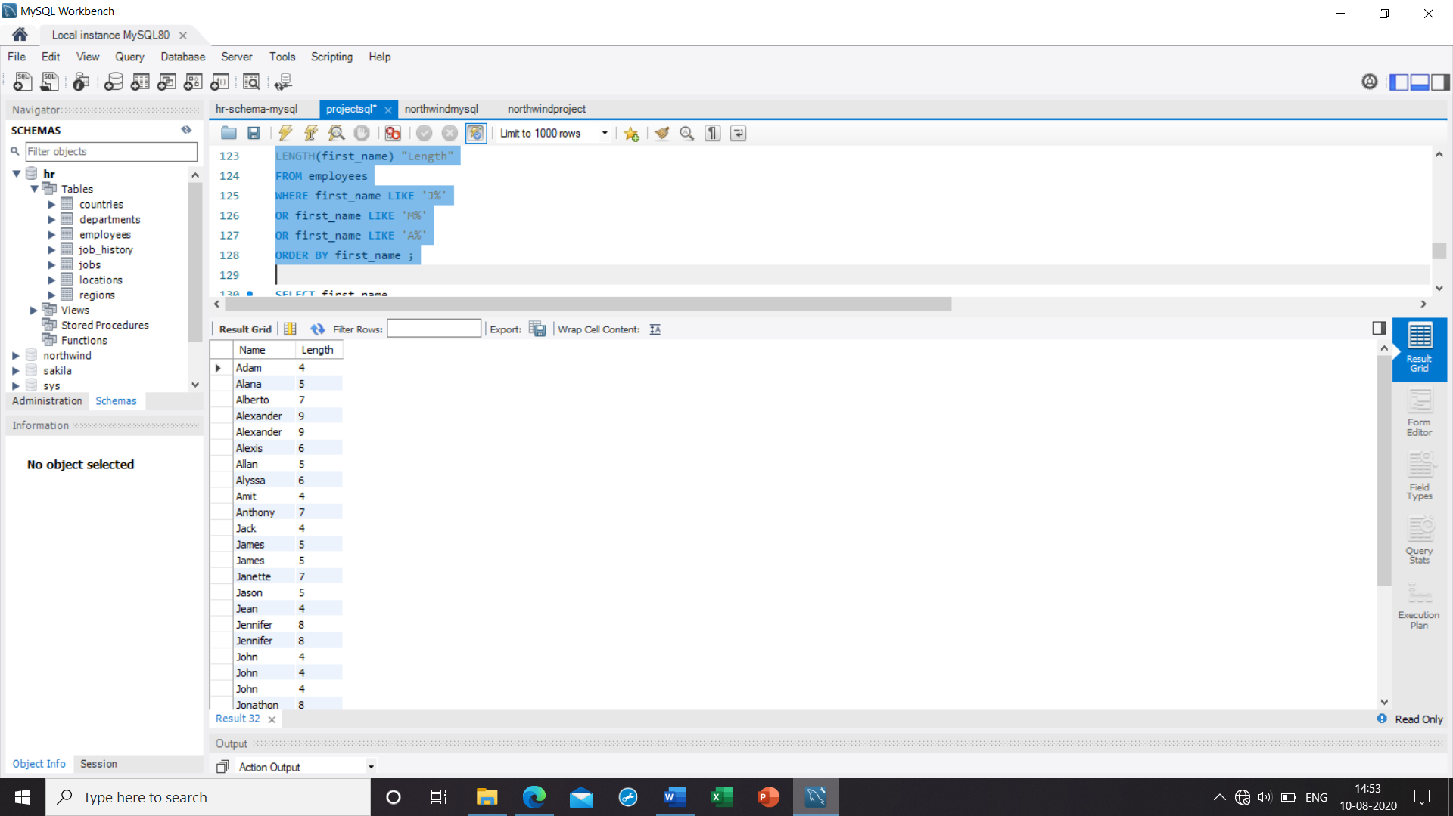

34. **Write a query to display the first name and salary for all employees. Format the salary to be 10 characters long, left-padded with the $ symbol. Label the column SALARY**

Ans. SELECT first_name,

LPAD(salary, 10, '$') SALARY

FROM employees;

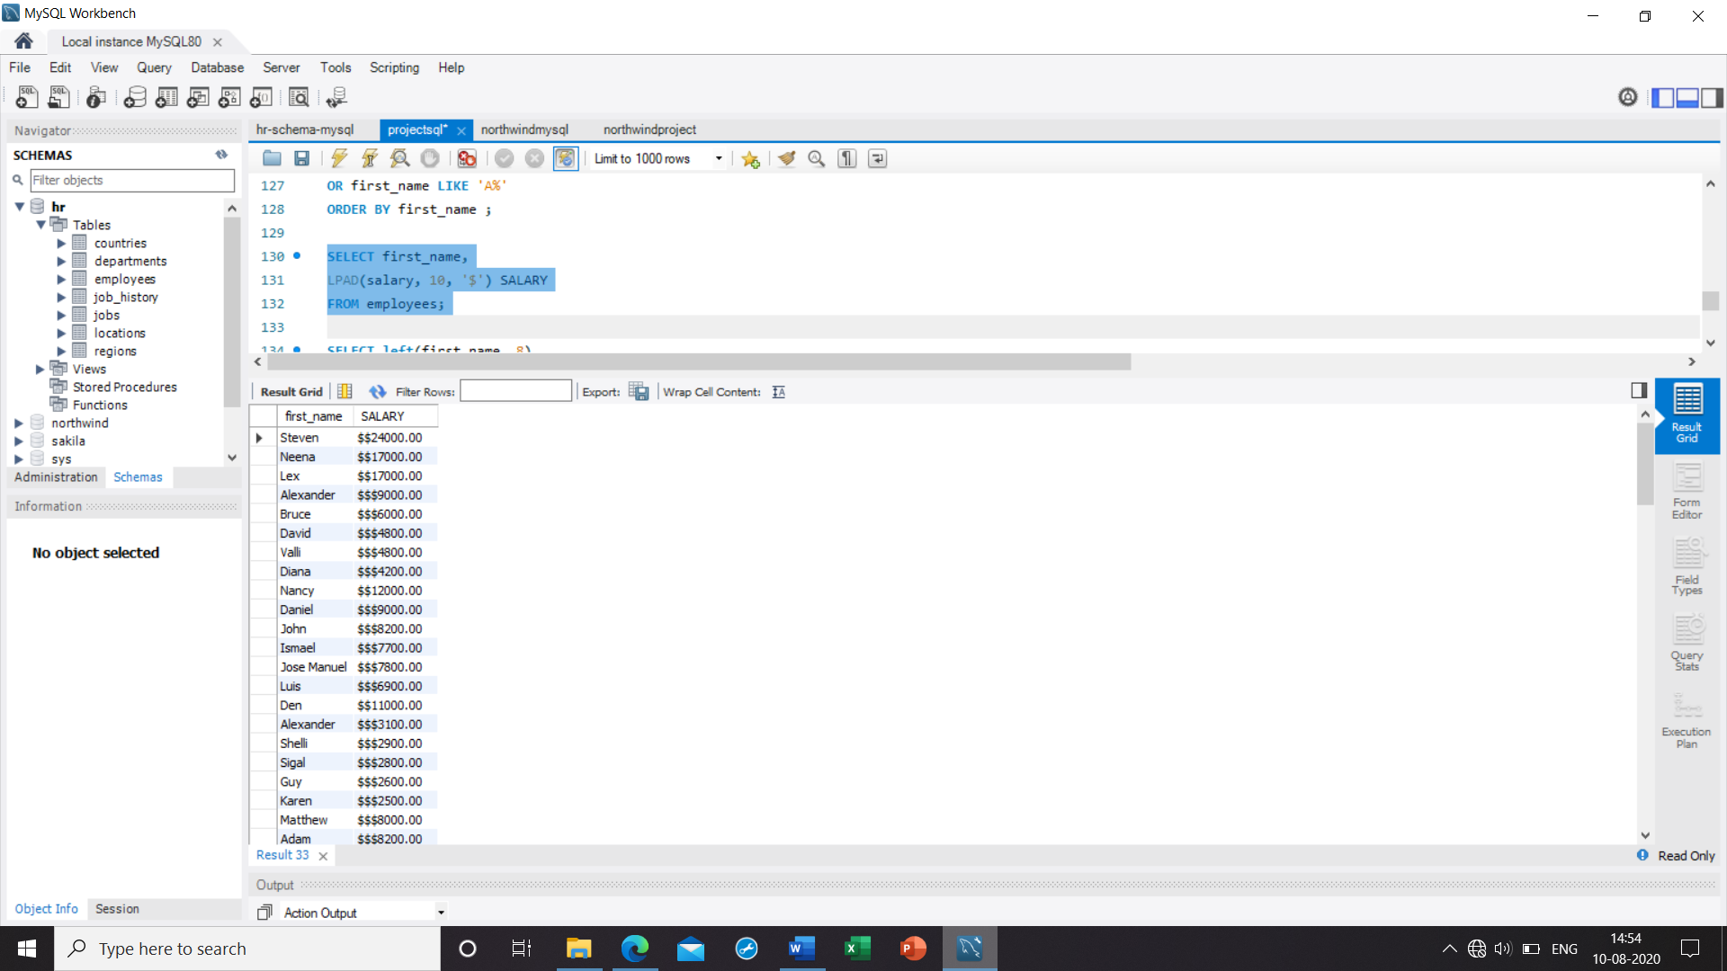

35**. Write a query to display the first eight characters of the employees' first names and indicates the amounts of their salaries with '$' sign. Each '$' sign signifies a thousand dollars. Sort the data in descending order of salary**

Ans. SELECT left(first_name, 8),

REPEAT('$', FLOOR(salary/1000))

'SALARY($)', salary

FROM employees

ORDER BY salary DESC;

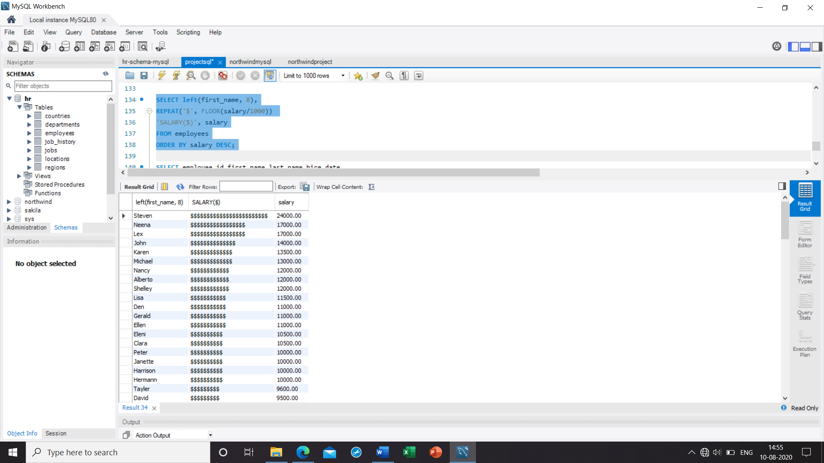

36**. Write a query to display the employees with their code, first name, last name and hire**

**date who hired either on seventh day of any month or seventh month in any year**

Ans. SELECT employee_id,first_name,last_name,hire_date

FROM employees

WHERE POSITION("07" IN DATE_FORMAT(hire_date, '%d %m %Y'))>0;

